**Program Document.**

Design and Develop a Simple Program



Contents

**Program Design Progress** **4**

Ideas. 4

Final Choice. 4

MindMaps. 5

FlowChart. 5

**Research** **6**

What are text based games? 6

How do text based games work and how well do they do? 6

Games similar to my idea. 6

What people think/enjoy of text based games. 6

What makes a good text-based game? 6

**References** **7**

**Program Design Progress** **4**

Ideas. 4

Final Choice. 4

MindMaps. 5

FlowChart. 5

**Research** **6**

What are text based games? 6

How do text based games work and how well do they do? 6

Games similar to my idea. 6

What people think/enjoy of text based games. 6

What makes a good text-based game? 6

**References** **7**

# Program Design Progress

## **Ideas.**

1. You are a traveler in search of the most valuable item but come across a lot of others doing the same thing as you, making you have to fight or dodge them each time.
2. You are a huntsman given a target to capture alive or dead, but you don't realise that your target is a skilled ex-huntsman like yourself until you start getting closer to your target.
3. You are on a journey to see if you are the only one like your kind left, you are a zombie but able to speak and seem very human-like unlike the other undead around you.
4. You are an leader of an adventuring group finding out there is a demon terrorizing the village near by in the forest, so you send your adventuring group that came with you off to investigate the area while you search for an important item that you heard rumours about then go to help you adventures.

## **Final Choice.**

The idea that I will be going with is number forth, because i asked people which idea they liked most and a lot of people liked second and forth but the forth won by 1 point compared to the second, but it was a very close one for them as both were good ideas.

I also like this to be more of a story based text game then a full text game where you have to do a lot of choice making.

## **MindMaps.**

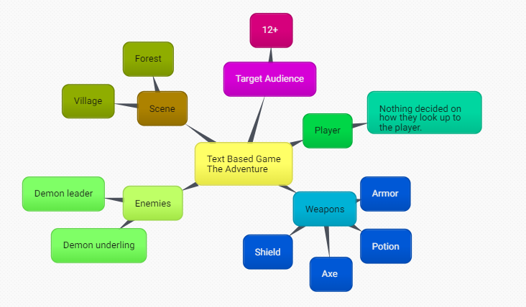

## **FlowChart.**

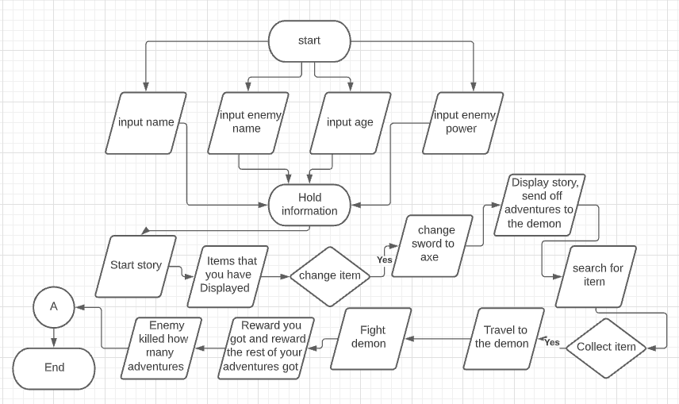

# 

# Research

## **What are text based games?**

Text based games are electronic games that use text based user interfaces. That is the user interface employs a set of encodable characters such as ASCII, instead of bitmap or vector graphics.

## **How do text based games work and how well do they do?**

Text based adventure is one of the oldest types of computer games that form a subset of the adventure genre. The player uses text input to control the game, while the game state is relayed to the player in text output.

## **Games similar to my idea.**

Destiny2- This game is similar to the idea I have because you are a part of a team that are on missions to find and get cool items and to follow the story along while fighting creatures.

Demon Slayer- This game is similar to my game because your goal is to track down a demon who did something bad to your family. This is similar to mine as you track it down for the villagers so it stops harassing them.

## **What people think/enjoy of text based games.**

From what I have found, people like text-based games because of the imagination when reading text-based games. It's easy to use and understand what to do.

Some people say it's best of both worlds of some of the worlds games, as in the power you have to the story to how you yourself would respond. You can imagine yourself as a character, how your enemy looks at everything, giving the player more fun in that aspect.

## **What makes a good text-based game?**

The tips I found to make a good text-based game were: play one, start small, Define a scope for your adventure, describe the settings and directions in a clear and specific way, the text commands need to be instinctive, be creative, test your game to exhaustion.

These are only a few examples of the tips I had found.

# 

# References

Singh, A. N/A. How to Make a Text-Based Game. [online] Available at: <https://levelskip.com/classic/Make-a-Text-Based-Game>

Wikipedia. 2021. Text-based game. [online] Available at: <https://en.wikipedia.org/wiki/Text-based_game#:~:text=A%20text%20game%20or%20text,of%20bitmap%20or%20vector%20graphics>.

Wikipedia. 2020. Interactive fiction. [online] Available at: <https://en.wikipedia.org/wiki/Interactive_fiction>

Lukas Ponik. 2013. C++ Text based adventure game. [online] Available at: <https://www.youtube.com/watch?v=oqvNEI6Wf2A>

Technivorous 3d Printing. N/A. C# Coding live! Choose your own demise! Text Based Game. [online] Available at: <https://www.youtube.com/watch?v=CnIHIitJ8EA>

quora.com. 2018. Why do people enjoy text-based games so much? [online] Available at:<https://www.quora.com/Why-do-people-enjoy-text-based-games-so-much>

Abluquerque, M. 2020. 13 Tips for writing a good text adventure game. [online] Available at:<https://www.davidepesce.com/2020/02/26/13-tips-for-writing-a-good-text-adventure-game/>

Wikipedia. N/A. Destiny 2. [online] Available at:<https://en.wikipedia.org/wiki/Destiny_2>

PowerPyx. 2017. Destiny 2 Enemies. [online] Available at: <https://www.powerpyx.com/destiny-2-enemies/>

Destiny 2 Wiki. N/A. Enemies (Destiny 2). [online] Available at:<https://destiny2-archive.fandom.com/wiki/Enemies_(Destiny_2)>

Steam. 2021. Demon Slayer - Kimetsu no Yaiba - The Hinokami. [online] Available at:<https://store.steampowered.com/app/1490890/Demon_Slayer_Kimetsu_no_Yaiba_The_Hinokami_Chronicles/>